Experiment 14
Aim
To implement the Alpha-Beta Pruning algorithm in Python for a two-player game to find the optimal move while reducing the number of nodes evaluated by Minimax.
Program
- Start
- Initialize the game board.
- Define the winning conditions.
- Set Alpha = −∞ and Beta = +∞.
- Check whether the current game state is a win, loss, or draw.
- If the computer wins, return a positive score.
- If the human player wins, return a negative score.
- If the game is a draw, return 0.
- Generate all possible moves.
- For the MIN player (Human):
- Select the minimum score.
- Update Beta.uuuuuuuuuuuuuuuuuuuuuuuuuu
- If Beta ≤ Alpha, stop evaluating the remaining branches (prune).
- Undo the current move.
- Continue until the best move is found.
- Make the computer's best move.
- Repeat until the game ends.
- Display the winner or draw.
- Stop.
Code:
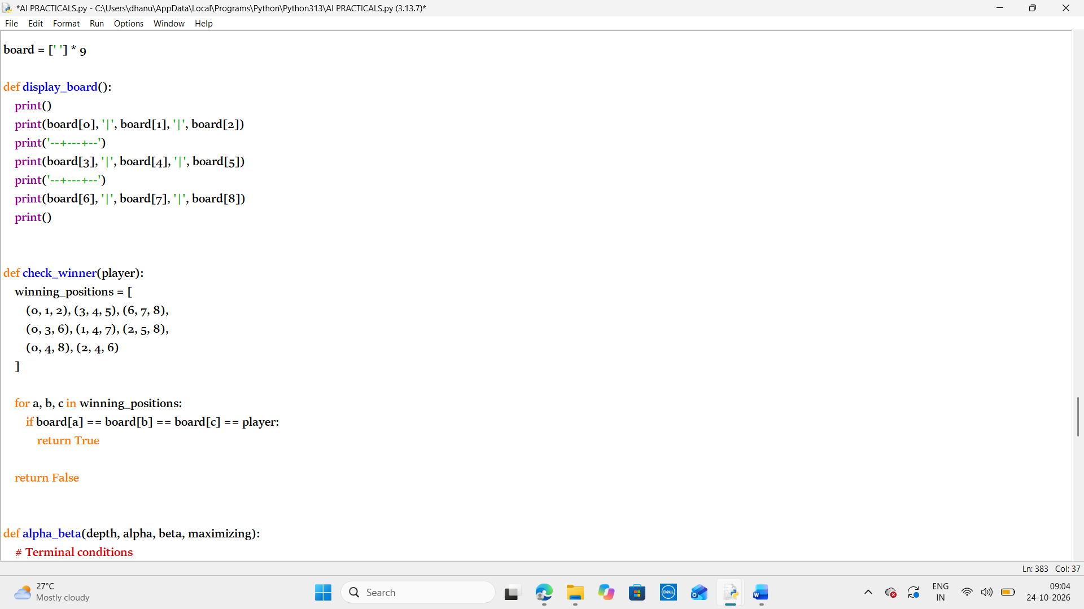
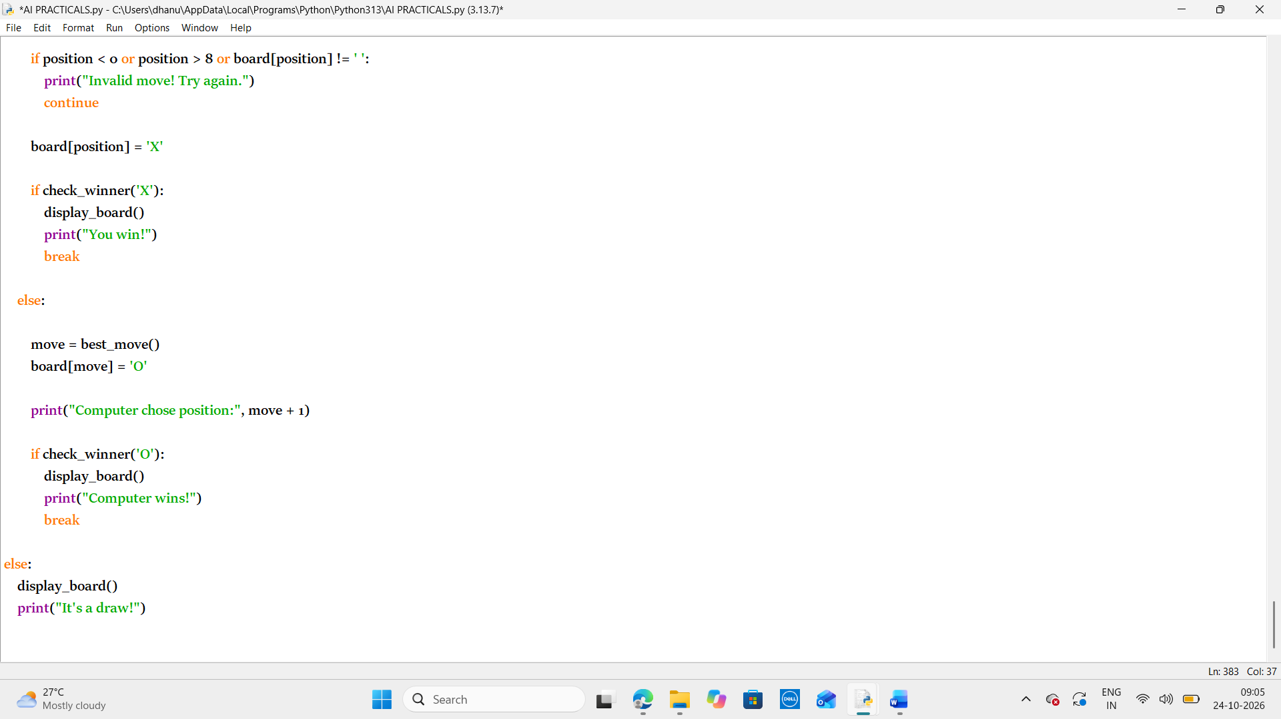
Output:
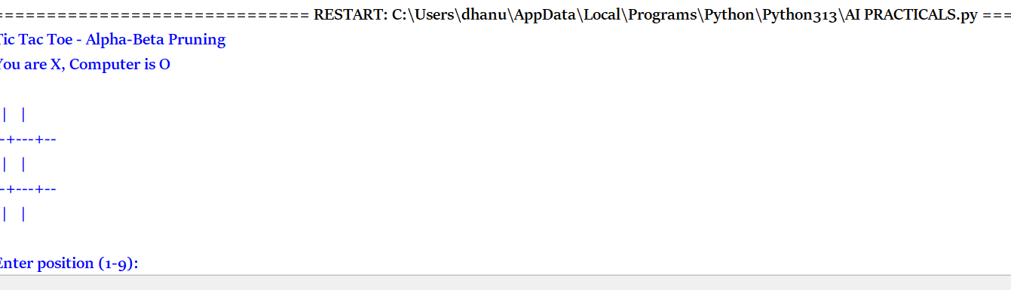result:
Thus the python program to implement the Alpha-Beta Pruning algorithm in Python for a two-player game to find the optimal move while reducing the number of nodes evaluated by Minimax has been executed successfully

